This is a little advanced I will admit, but if you are curious then read on ...
Let's look at the example of this line of code that we have written in our Node file:
const express = require(‘express’);
Where does Node know where to find this module? As I mentioned earlier, I have not installed the Express framework locally in my project folder. I have Express installed globally on my machine.
Here is where it is located on my machine:

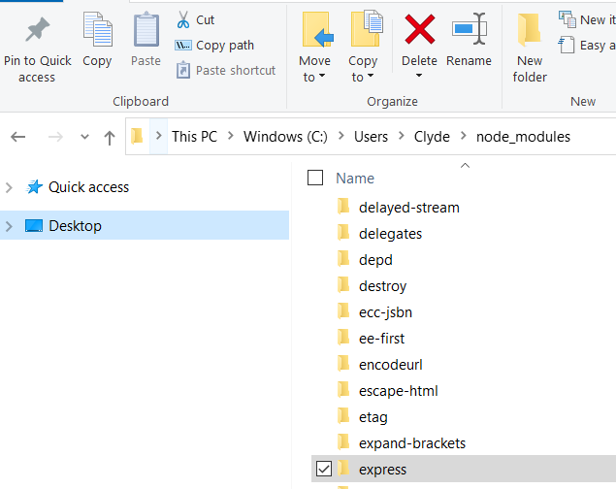

Where does Node look to find the required module?
Let me say off the bat, that Node.js uses a complex algorithm to locate the requested module.
It first determines whether the named module is whats known as a core module. A core module is installed directly when you install Node. It comes shipped with Node. Examples of core modules are the HTTP module, FS module, and the Events module. There are a lot more.
These core modules will load first and will therefore load very fast in Node’s loading algorithm.
“But Clyde, what if the named module is not a core module? Where does Node then look?”
Great question.
Our Express module is not a core module.
In this case, Node will then look for a directory named, "node_modules". It will start in the current directory. Remember a few lectures back, in the article I mentioned that you have the option of installing Express locally in your folder. If it’s not there, Node will work its way up the folder hierarchy, checking each level for a node_modules folder.
In my example screenshot above, Node will continue to search until it finds Express here: C:\Users\Clyde\node_modules
This will cover most instances of modules. However, if Node still doesn’t find it, it does a few other checks that I don't want to discuss here.
Bottom line: Node performs a complex searching algorithm when trying to find a module that you require.

